Set up POP3/IMAP email - Apple iPhone 7 Plus
1

Before you start
Make sure you have the following information: 1. Your email address 2. Password 3. Username Internet must be set up before you start this guide.
2

Select Settings
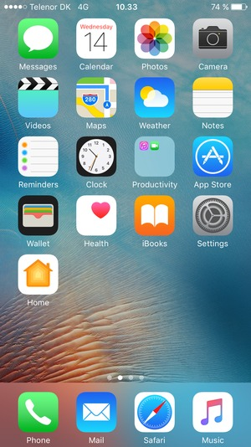

3 Scroll to and select Mail
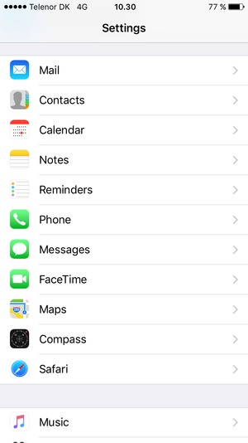

4 Select Add Account

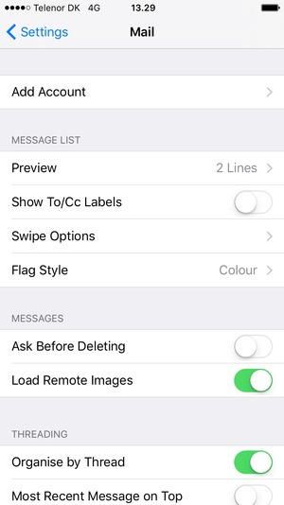

5 Select Other

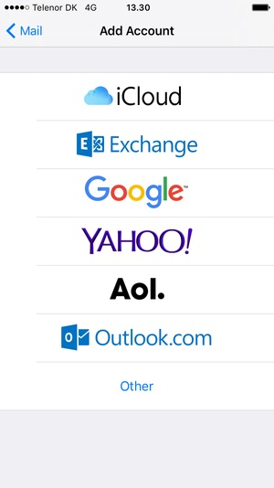

6 Select Add Mail Account

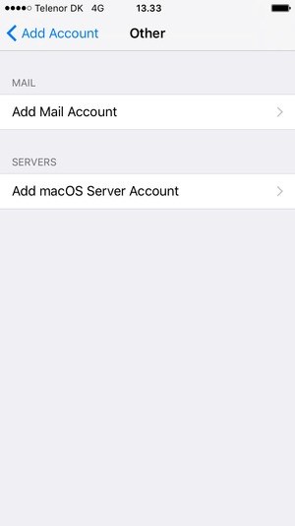
7

Enter the required information and select Next
Note: the Password is case-sensitive.
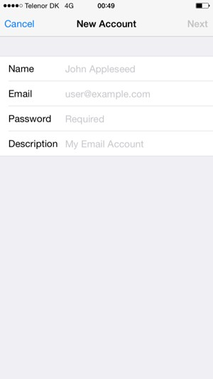
Your name
Email address
Password
8 Select POP or IMAP and enter email information for Incoming Mail Server
Note: the Password is case-sensitive
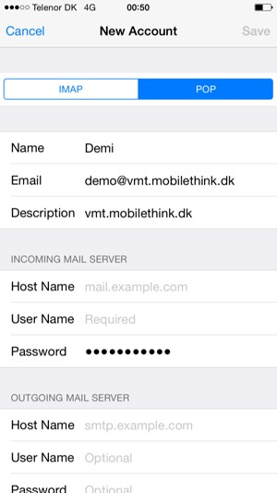
User name
Password
9 Enter email information for Outgoing Mail Server and select Save
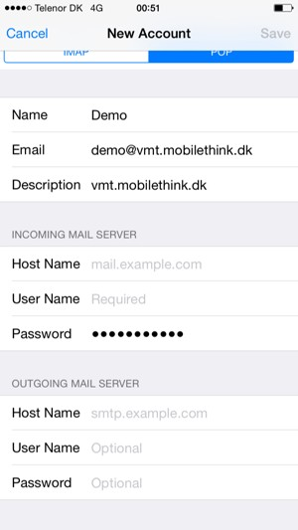
10 Your account is ready to use

